## Name: Laura C. Larregui Date: February 12, 2020

## Lab 05 - Physical Design and DDL

Part 1 – Creating Tables

1. User Table

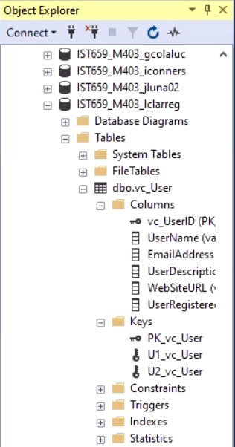

1. User Login Table

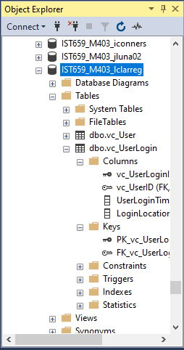

1. User Records

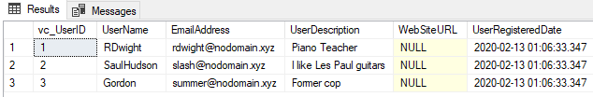

1. User Tables

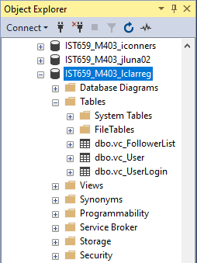

1. VidCast Table

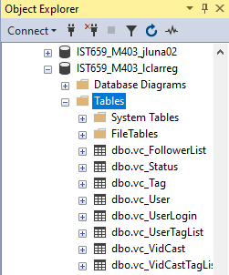

Part 2 – The Rest of the Tables

1. SQL query file

/*

Author: Laura Larregui

Course: IST659 M403

Term: Winter 2020

*/

--Creating first table

Create table vc_User (

vc_UserID int identity,

UserName varchar(20) NOT NULL,

EmailAddress varchar(50) NOT NULL,

UserDescription varchar(200),

WebSiteURL varchar(50),

UserRegisteredDate datetime NOT NULL default GetDate(),

--constraints

constraint PK_vc_User Primary key (vc_UserID),

constraint U1_vc_User unique(UserName),

constraint U2_vc_User unique(EmailAddress)

)

--Creating second table

Create table vc_UserLogin (

vc_UserLoginID int identity,

vc_UserID int NOT NULL,

UserLoginTimestamp datetime NOT NULL default GetDate(),

LoginLocation varchar(50) NOT NULL,

--constraints

constraint PK_vc_UserLogin Primary key (vc_UserLoginID),

constraint FK_vc_UserLogin Foreign Key (vc_UserID) references vc_User(vc_UserID)

)

--adding data to the user table

insert into vc_User(UserName, EmailAddress, UserDescription)

values

('RDwight', 'rdwight@nodomain.xyz', 'Piano Teacher'),

('SaulHudson', 'slash@nodomain.xyz', 'I like Les Paul guitars'),

('Gordon', 'summer@nodomain.xyz', 'Former cop')

select * from vc_User

--Creating third table

Create table vc_FollowerList (

vc_FollowerListID int identity,

FollowerID int NOT NULL,

FollowedID int NOT NULL,

FollowerSince datetime NOT NULL,

--constraints

constraint PK_vc_FollowerList Primary key (vc_FollowerListID),

constraint U1_vc_FollowerList  Unique (FollowerID, FollowedID),

constraint FK1_vc_FollowerList Foreign Key (FollowerID) references vc_User(vc_UserID),

constraint FK2_vc_FollowerList Foreign Key (FollowedID) references vc_User(vc_UserID),

)

--Creating tag table

Create table vc_Tag (

vc_TagID int identity,

TagText varchar(20) NOT NULL,

TagDescription varchar(100),

--constraints

constraint PK_vc_Tag Primary key (vc_TagID),

constraint U1_vc_Tag  Unique (TagText)

)

--Creating status table

Create table vc_Status (

vc_StatusID int identity,

StatusText varchar(20),

--constraints

constraint PK_vc_Status Primary key (vc_StatusID),

constraint U1_vc_Status Unique (StatusText)

)

--Creating VidCast table

Create table vc_VidCast (

vc_VidCastID int identity,

VidCastTitle varchar(50) NOT NULL,

StartDateTime datetime,

EndDateTime datetime,

ScheduledDurationMinutes int,

RecordingURL varchar(50),

vc_UserID int NOT NULL,

vc_StatusID int NOT NULL,

--constraints

constraint PK_vc_VidCast Primary key (vc_VidCastID),

constraint FK1_vc_VidCast Foreign Key (vc_UserID) references vc_User(vc_UserID),

constraint FK2_vc_VidCast Foreign Key (vc_StatusID) references vc_Status(vc_StatusID),

)

--Creating VidCastTagList table

Create table vc_VidCastTagList (

vc_VidCastTagListID int identity,

vc_TagID int NOT NULL,

vc_VidCastID int NOT NULL,

--constraints

constraint PK_vc_VidCastTagList Primary key (vc_VidCastTagListID),

constraint U1_vc_VidCastTagList Unique (vc_TagID, vc_VidCastID),

constraint FK1_vc_VidCastTagList Foreign Key (vc_TagID) references vc_Tag(vc_TagID),

constraint FK2_vc_VidCastTagList Foreign Key (vc_VidCastID) references vc_VidCast(vc_VidCastID)

)

--Creating UserTagList table

Create table vc_UserTagList (

vc_UserTagListID int identity,

vc_TagID int NOT NULL,

vc_UserID int NOT NULL,

--constraints

constraint PK_vc_UserTagList Primary key (vc_UserTagListID),

constraint U1_vc_UserTagList Unique (vc_TagID, vc_UserID),

constraint FK1_vc_UserTagList Foreign Key (vc_TagID) references vc_Tag(vc_TagID),

constraint FK2_vc_UserTagList Foreign Key (vc_UserID) references vc_User(vc_UserID)

)